**FRINGE BENEFITS**

1. **Summary**

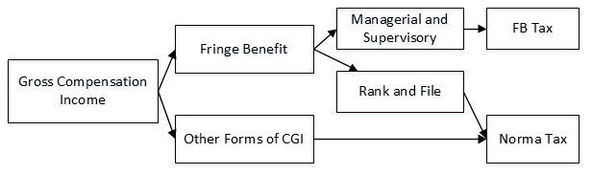

1. **General Rule on Computation of FB Tax**

FB Tax = MV * GUMV % * FB Tax %

|  |  |  |
| --- | --- | --- |
| **Housing or Vehicle FB** | **Value of Benefit** | **Monetary Value** |
| Leased property | Rental paid | MV = Value of Benefit * Factor  Factor is:   * Transfer of ownership – 100% * No transfer – 50% |
| Property purchased on installment | Annual installment equivalent |
| Property purchased/owned but not ownership not transferred | Annual depreciation equivalent |
| Property purchased/owned and ownership not transferred | Housing = FMV, ZV, or AC ↑  Vehicles = AC |

Note:

If FB is in the form of money or directly paid to employee, the MV is the amount granted or paid.

1. **Other Forms of FB**
2. Foreign Travel Benefits

|  |
| --- |
| Exempt:   1. Econ and business class tickets 2. 70% of 1st class tickets 3. Lodging cost in a hotel at an average of US $300 or less per day in foreign or inland travel. 4. Other reasonable business expense   Provided:   1. To attend business meetings and conventions 2. Supported by documents. |

1. Interest on loan at less than market

MV = interest forgone

1. Life, health and other non-life insurance premiums – In general, taxable

|  |
| --- |
| Exempt:   1. SSS 2. GSIS 3. Similar contributions under existing laws 4. Premiums for group insurance of employees |

1. Educational Benefits

|  |
| --- |
| In general, taxable provided:   1. Directly connected to employer’s trade 2. Granted to competition scheme under scholarship |